

American International University-Bangladesh (AIUB)  
**Department of Computer Science  
Faculty of Science & Technology (FST)**

**Medicine Delivery Chain - Smart Solution for**

**Medicine Suggestion and Delivery**

A Software Requirement Engineering Project Submitted

By

|  |  |  |  |  |
| --- | --- | --- | --- | --- |
| **Semester: Spring_24_25** | | **Section:** | **Group Number:** | |
| SN | Student Name | Student ID | Contribution in % (100%) | Individual Marks |
| 19 | FARDIL CHOWDHURY | 22-46109-1 | 25% |  |
| 18 | SHUVO CHANDRA MALI | 21-45971-3 | 25% |  |
| 26 | DHURBO CHANDRA ROY | 22-46630-1 | 25% |  |
| 7 | Md Mochaddec Hossain | 21-45591-3 | 25% |  |

The project will be Evaluated for the following Course Outcomes

|  |  |  |
| --- | --- | --- |
| **EVALUATION CRITERIA** | Total Marks (50) | |
| 40 | |
| Introduction [Section 1.1-1.4], Format, Submission, Defense | [10 Marks] |  |
| System Overall Description & Functional Requirements | [10 Marks] |  |
| System Quality Attributes and Project Requirements | [10 Marks] |  |
| UML and E-R Diagram with Data Dictionary | [10 Marks] |  |
| UI/UX Prototyping | [10 Marks] |  |

Software Requirements Specification

for

< Medicine Delivery Chain - Smart Solution for  
Medicine Suggestion and Delivery >

Version 1.7 approved

Prepared by

<DHURBO CHANDRA ROY, SHUVO CHANDRA MALI, FARDIL CHOWDHURY, Md Mochaddec Hossain >

< American International University-Bangladesh >

< 17 June 2025>

Table of Contents

Revision History 4

1. Introduction 4

1.1 Purpose 4

1.2 Document Conventions 5

1.3 Intended Audience and Reading Suggestions 6

1.4 References 8

2. Overall Description 8

2.1 Product Perspective 8

2.2 Product Functions 9

2.3 User Classes and Characteristics 10

2.4 Hardware and Operating Environment 10

2.5 Design and Implementation Constraints 11

2.6 User Documentation 12

3. System Requirements 14

3.1 System Features 14

3.1.1 Software Login **Error! Bookmark not defined.**

3.2 Non-Functional/Quality Requirements 17

3.3 Project Requirements 19

4. Design and Interface Requirements 23

4.1 UML Diagrams 23

4.2 Data Dictionary 27

4.3 UI/UX Design Specification 28

# Revision History

|  |  |  |  |
| --- | --- | --- | --- |
| **Name** | **Date** | **Reason for Changes** | **Version** |
| FARDIL CHOWDHURY | 26-05-25 | Initial draft of SRS for AgriChain, defining purpose, scope, and system requirements | 1.1 |
| DHURBO CHANDRA ROY | 28-05-25 | Added detailed functional requirements (Section 3.1) and initial UML diagrams (Section 4.1) | 1.2 |
| FARDIL CHOWDHURY | 30-05-25 | Updated non-functional requirements (Section 3.2) and integrated stakeholder feedback on UI/UX (Section 4.3) | 1.3 |
| DHURBO CHANDRA ROY | 3-06-25 | Finalized data dictionary (Section 4.2) and added Bangla language support specifications | 1.4 |
|  | 4-06-25 | Revised hardware and operating environment (Section 2.4) to optimize for low-cost devices | 1.5 |
| SHUVO CHANDRA MALI | 12-06-25 | Updated smart contract specifications and added regulatory compliance details (Section 2.5) | 1.6 |
|  | 16-06-25 | Final review and formatting adjustments to ensure compliance with AIUB guidelines | 1.7 |

# Introduction

## Purpose

This **Software Requirements Specification (SRS)** outlines the requirements for the **Medicine Delivery Chain System (MDCS)**, a mobile and web-based platform designed to revolutionize healthcare accessibility in Bangladesh. MDCS addresses critical challenges in medicine procurement by:

* Providing **real-time medicine availability** at nearby pharmacies.
* Offering **AI-powered symptom analysis** and prescription-based medicine recommendations.
* Enabling **secure, multi-role coordination** among customers, pharmacists, riders, and administrators.

**Scope**:

* **User Interfaces**: Customer app (Android/iOS), pharmacist dashboard, rider dispatch system.
* **Core Features**:
  + Prescription validation via OCR/QR scanning.
  + GPS-enabled rider tracking with tamper-proof delivery.
  + Multi-payment integration (bKash, Nagad, cards, COD).
* **Strategic Goals**:
  + Reduce time spent searching for medicines (target: ≤3 minutes/order).
  + Improve rural healthcare access (aligns with Bangladesh Digital Health Strategy).
  + Minimize prescription fraud (HIPAA-compliant data encryption).

**Business Needs**:

1. **AI-Driven Healthcare**:
   * Symptom-to-medicine mapping with 85% accuracy.
   * Emergency triage alerts for critical conditions.
2. **Logistics Efficiency**:
   * Automated rider assignment (≤5km radius prioritization).
   * Real-time order status updates.
3. **Regulatory Compliance**:
   * Bangladesh Digital Security Act adherence.
   * Controlled substance tracking (e.g., opioids).

## Document Conventions

This document follows standardized formatting and notation rules to ensure clarity and consistency for all stakeholders.

**1. Formatting Standards**

* **Fonts**:
  + Body text: Times New Roman 12pt (justified)
  + Headings: Level 1 (14pt bold), Level 2 (12pt bold)
* **Spacing**:
  + 1.0 line spacing for text, 1.15 for lists
  + 0.5" first-line paragraph indentation

**2. Requirement Classification**

* **Priority Levels**:
  + **High (H)**: Core features (e.g., prescription validation)
  + **Medium (M)**: Important but deferrable (e.g., multi-language support)
  + **Low (L)**: Future enhancements
* **Component Ratings**: 1-9 scores for Benefit, Penalty, Cost, and Risk

**3. Special Notations**

* **\*** (Asterisk): Mandatory fields (e.g., Phone number*)
* *Italics*: Optional features (e.g., *voice commands*)
* Monospace: Technical elements (e.g., API endpoints)
* ⚠️ Triangle: Security warnings (e.g., ⚠️ 2FA required)
* **Bold**: Key terms (e.g., **HIPAA compliance**)
* ~~Strikethrough~~: Deprecated features

**4. Cross-Referencing**

* Internal links: "See Section 3.1.2 (FR-AI2)"
* External standards: HIPAA, Bangladesh DSA

**5. Revision Tracking**

* Version numbers: v1.0 (major), v1.1 (minor)
* Marginal comments for changes

**6. Accessibility**

* Color codes: Red (errors), Green (success)
* Alt text for all images/diagrams

## Intended Audience and Reading Suggestions

This Software Requirements Specification (SRS) document is intended for a wide range of stakeholders involved in the development and implementation of the Medicine Delivery Chain System (MDCS). The document provides detailed requirements for the system, which will guide developers, healthcare providers, and other relevant team members throughout the software lifecycle. The intended audience includes:

* **Developers:**  
  Refer to this document for details on required system features to implement the architecture and interfaces accurately, including:
  + AI-powered symptom analysis (Section 3.1.2)
  + Prescription verification workflows (Section 3.1.2)
  + Multi-role authentication (Section 3.1.1)
* **Project Managers:**  
  Use this SRS to:
  + Manage timelines using COCOMO estimates (Section 3.3)
  + Assign tasks based on priority levels (marked throughout Section 3)
  + Control scope with clearly defined constraints (Section 2.5)
* **Pharmacists/Healthcare Providers:**  
  Review requirements for:
  + Prescription validation protocols (FR-AI2 in Section 3.1.2)
  + Inventory management interfaces (FR-ORDER1 in Section 3.1.3)
* **Government Regulators (BMC, DSA):**  
  Verify compliance with:
  + Digital Security Act audit logs (QA10 in Section 3.2)
  + Controlled substance tracking (FR-AI3 in Section 3.1.2)
* **UI/UX Designers:**  
  Base interfaces on:
  + User class characteristics (Section 2.3)
  + Accessibility requirements (QA9 in Section 3.2)
  + Prototyping specifications (Section 4.3)
* **Quality Assurance Team:**  
  Develop test cases using:
  + Functional requirements (Section 3.1)
  + Non-functional metrics (Section 3.2)
  + Security validation points (QA6 in Section 3.2)

**Suggested Reading Path:**

1. **Start with Section 1 (Introduction)** for project purpose and scope.
2. **Proceed to Section 2 (Overall Description)** for product context and user roles.
3. **Study Section 3 (System Requirements)** for detailed functional and quality requirements.
4. **Refer to Section 4 (Design Requirements)** for UML diagrams and UI prototypes.

For quick reference:

* Pharmacists: Focus on Sections 2.3 + 3.1.3
* Developers: Prioritize Sections 3.1 + 4.1
* Regulators: Review QA6 + QA10 in Section 3.2

## References

1. **AI in Healthcare Delivery**
   * Topol, E. J. (2019). *Deep Medicine: How Artificial Intelligence Can Make Healthcare Human Again*. Basic Books.
   * *Relevance*: Supports your AI symptom checker and prescription validation features (Section 3.1.2).
2. **Blockchain for Drug Traceability**
   * Kshetri, N. (2022). *Blockchain and Sustainable Development Goals*. Springer.
   * *Relevance*: Validates your blockchain-based prescription audit trail (QA6).
3. **Regulatory Compliance**
   * Bangladesh Digital Security Act (2018). Government of Bangladesh.
   * HIPAA Journal. (2023). *HIPAA Compliance Checklist*. [https://www.hipaajournal.com](https://www.hipaajournal.com/)
   * *Relevance*: Critical for Sections 2.5 (Constraints) and QA10.

# Overall Description

## Product Perspective

The "Medicine Delivery Chain – Smart Solution for Medicine Suggestion and Delivery" system is an original, stand-alone application that targets addressing the problems people face in accessing health care and obtaining medicines, especially for those in remote communities or in cases of medical emergencies. It is not an addition or replacement for an existing system but a whole conception that interconnects various actors within the medicine delivery chain.

The platform is engineered to integrate various functions like AI-powered symptom analysis and medicine suggestion, secure prescription checking, order processing, delivery tracking, and fraud-proof payment gateway. The solution is imagined providing enhanced access to healthcare, enable faster delivery of medicine, enable expansion of local pharmacies, and equip consumers with more control over their healthcare needs from home.

## Product Functions

The main tasks of the “Medicine delivery Chain – Smart Solution for Medicine Suggestions and Delivery” application are:   
AI-Powered Medication Suggestion with Prescription Management: It accepts text or voice input for intelligent symptom analysis, generates differential diagnosis with confidence levels, and detects emergencies. It also validates prescriptions uploaded as PDFs or images by extracting doctor registration numbers (verified against BMC database), hospital seal verification, expiry date validation, and reading QR codes for e-prescriptions. Controls for controlled substances are also included, such as a red flag list and quantity controls.

Multi-Factor Authentication System: The application has role-based login processes for Customers, Pharmacists, Riders, and Admins with varying authentication methods like email/phone and password with SMS OTP, shop license number with fingerprint scanning, NID verification using live face recognition, and hardware token with IP whitelisting and biometric authentication, respectively. Security lockout for login failures and session management using auto-logoff and JWT token refresh are supported as well.

Safe Order Delivery & Delivery Tracking: The system maintains real-time inventory validation through scan of the five nearest pharmacies around a 5km radius and sorting the stores on dispatch time as well as customer ratings. The system includes rider safety features like live selfie matching before pickup, GPS geofencing during transit, and tamper-proof bag seals with individual QR codes at delivery. Customer verification is done through OTP-based delivery confirmation and voluntary biometric receipt acceptance.

Fraud-Resistant Payment Gateway: Multi-layered payment methods such as mobile payments (bKash/Nagad/Rocket with tokenized transactions), cards (Visa/Mastercard with 3D Secure 2.0), and Cash on Delivery (COD) with a maximum limit and ID verification are facilitated by the system. It also comes with anomaly detection to avoid fraudulent transactions.

## User Classes and Characteristics

The system accommodates various user classes, each with its own needs and attributes:

* **Customers:** Individuals using the app to decide on probable diseases based on symptoms, get medicine suggestions, and buy medicines for in-home delivery. They could be in remote areas or emergency situations. They require an easy-to-use interface for symptom input, prescription upload, and order submission. They utilize SMS OTP for login and delivery confirmation.
* **Pharmacists:** Proprietors and personnel of the network pharmacy. They have to manage stock, order stock, and dispense prescriptions. Login involves a shop license number, finger scan, and admin approval. They have the responsibility to keep stock of medicines and ship orders within time.
* **Riders:** Individuals responsible for picking up medicines from pharmacies and delivering them to customers. Their job requires secure pickup and transport procedures, like NID verification, live facial recognition, background screening, and GPS geofencing. Riders have interactions with tamper-evident bag seals and QR codes for secure delivery.
* **Admins:** Senior users who have access to manage the system, attest to pharmacist registrations, intervene when accounts are irretrievably locked, and administer general functions. Their authentication is through hardware tokens, IP whitelisting, and biometric verification. They are responsible for security and compliance.

## Hardware and Operating Environment

The application will be executed in an environment that is friendly to its multi-platform aspect and real-time operation.

* **Target Devices:** The system will be used through mobile devices by Riders and Customers, and web interfaces by Pharmacists and Admins for executing their respective functionalities.
* **Operating Systems:** Popular mobile operating systems (Android, iOS) and web browsers need to be supported to provide widespread user access.
* **Network Requirements:** Reliable internet connection is a necessity for real-time features such as AI symptom diagnosis, checking of prescriptions, stock checks, tracking of deliveries, and online payments.
* **Backend Infrastructure:** There will be a considerable demand for a backend to facilitate secure storage of data, AI model processing, authentication service, payment gateway integrations, and notification services. Encryption mechanisms such as AES-256 for OTPs, crypts for password storage, and HIPAA-compliant encryption for health data indicate the need for secure server infrastructure. The mention of blockchain-based audit trails in prescribing access management also indicates the need for distributed ledger technology integration.
* **Third-Party Integration:** Third-party services such as BMC database for cross-checking doctor registration number, GPS service for geofencing and live tracking, and various payment gateways such as bKash, Nagad, Rocket, Visa, and Mastercard will be integrated into the system.

## Design and Implementation Constraints

The implementation and design of the "Medicine Delivery Chain – Smart Solution for Medicine Suggestion and Delivery" system will be guided by certain constraints to make it secure, safe, and deploy successfully.

**Regulatory Constraints:**

* The app must comply strictly with local laws and regulations on data security and privacy, especially when it comes to health information.
* Prescription verification procedures must comply with current pharma and medical regulations, including cross-checking against the BMC database for doctor registration numbers.
* Red-flag lists and quantity limits for controlled drugs must comply with national pharma guidelines.
* Payment gateway transactions must comply with financial standards and regulations, e.g., PCI DSS Level 1 compliance.
* Compliance audit logs must be retained for 7 years with automatic backups.

**Technical Constraints:**

* All role user authentication must be ensured through robust security measures like AES-256 encryption for SMS OTP, bcrypt password hashing with 12 rounds of salt, and JWT token refresh mechanisms.
* NLP processing for text/voice input must be enabled in the AI-based medicine suggestion system and, optionally, integration with large language models or other AI services might be required.
* Prescription verification will necessitate OCR for text extraction from PDF/image uploads and pattern matching for checking the hospital seal.
* The system will need to integrate well with third-party solutions such as GPS for geofencing and real-time tracking of riders, payment gateways (bKash, Nagad, Rocket, Visa, Mastercard), and maybe a blockchain for prescription audit trails.
* All health data and payment data will have to be protected with HIPAA-compliant encryption of data and masked card numbers in logs.
* Inventory counts in real-time will require swift retrieval of data from networked pharmacies within a specified radius (5km).
* The system must be high-performance optimized, with AI symptom analysis response times less than 2.5 seconds for 95% of queries.

**Security Constraints:**

* The system must implement multi-factor authentication for all user types, with specific protocol for Admins, Pharmacists, Riders, and Customers.
* Security lockout features to discourage multiple failed login attempts, temporary, and permanent freezing of accounts should be utilized.
* Device fingerprinting should track login attempts.
* Uploaded prescriptions must watermark with user ID and timestamp for increased security.
* Live tracking of riders must include an SOS panic button, and delivery activities must integrate tamper-evident bag seals with individual QR codes.
* Medicine barcode scanning must be implemented at delivery and pickup points.
* Encrypted order history must be stored and maintained for 180 days.
* The payment gateway must also have anomaly detection to identify abnormal transactions.
* A 3-month exclusive security testing duration is planned, with Burp Suite, Hashcat, and AWS KMS being the tools used. Two OWASP-certified security engineers are part of the team.

**Development Constraints:**

Development timeline is 11 months.

Project budget is ৳1,500,000 with exclusive earmark for security (35%) and AI (30%).

The development team comprises 2 Security Engineers, 3 AI/ML Developers, and 4 QA Testers.

Specific compliance (GDPR/PCI DSS checklist automation) and test (Selenium, Postman, JMeter) tools have been identified.

Version 1.7 of the software is the target of this SRS.

## User Documentation

Comprehensive user documentation will be provided to facilitate all stakeholders using the "Medicine Delivery Chain – Smart Solution for Medicine Suggestion and Delivery" system effectively.

**Customer User Manual:**

* Step-by-step instructions on how to download, install, and use the mobile application.
* Step-by-step steps for entry of symptoms, interpretation of AI suggestions, uploading and approval of prescriptions, ordering, and following delivery.
* Information regarding management of payment modes and interpretation of security features like OTP-based delivery confirmation.
* Solution to frequently encountered problems.

**Pharmacist Guide:**

* Steps in managing stock, refilling medicine stocks, processing incoming orders, and managing dispatch.
* Guidelines on operating the pharmacist login procedures, including fingerprint verification.
* Information on operating features related to confirmation of prescriptions and controlled substance safety.

**Rider Guide :**

* Instructions for use of the mobile app in live selfie match, reading GPS geofencing notifications, and handling tamper-evident bag seals with QR codes.
* Procedures for verification of delivery (OTP-based and optional biometric verification).
* Instructions on SOS panic button use.
* Instructions for receipting and handling delivery orders.

**Admin Documentation:**

* Comprehensive guide for system administration, user approvals (for example, pharmacist approval), freeze handling for accounts, monitoring of system performance, and generation of reports.
* Description of accessing and reading audit logs and security configurations.
* Information on system integration management and compliance issues.
* In-App Tutorials/Onboarding:
* Short, interactive tutorials for new users (specifically Customers and Riders) to learn basic functionalities right away.

**Online Help Center/FAQ:**

* A distinct section in the application or website to handle frequently asked questions and general user inquiries.
* Facility for contact support information (for example, email or chat support).

**Format and Delivery:**

* Documentation will exist in electronic formats (e.g., PDF, in-app docs).
* All documentation will aim to employ plain, clear language, adhering to the document conventions outlined in Section 1.2.
* User roles like "Admin", "Customer", "Pharmacist", and "Rider" will be always capitalized.

# System Requirements

## System Features

**3.1.1 Multi-Factor Authentication System**

**Functional Requirements (FRs):**

1. **FR-AUTH1**: Role-based login protocols:
2. Customers: Email/Phone + Password + SMS OTP (AES-256 encrypted)
3. Pharmacists: Shop License No. + Fingerprint Scan + Admin Approval
4. Riders: NID Verification + Live Facial Recognition + Background Check
5. Admins: Hardware Token + IP Whitelisting + Biometric Auth
6. **FR-AUTH2**: Security lockout mechanism:
   1. 3 failed attempts → Temporary lock (1 hour) + Email Alert
   2. 5 failed attempts → Permanent freeze (requires admin intervention)
7. **FR-AUTH3**: Session management:
   1. Auto-logout after 15 minutes of inactivity
   2. JWT token refresh every 30 minutes

**Security Features:**

1. bcrypt password hashing with 12-round salt
2. All OTPs valid for 90 seconds only
3. Login attempts logged with device fingerprinting

**Priority Level:** High  
**Precondition:** Valid credentials for respective roles  
**Cross-references:** 4.1 (UML Auth Sequence Diagram), 7.2 (Encryption Standards)

**3.1.2 AI-Powered Medicine Suggestion with Prescription Control**

**Functional Requirements (FRs):**

1. **FR-AI1**: Intelligent symptom analysis:
   1. Accepts text/voice input (NLP processing)
   2. Generates differential diagnosis with confidence scores
   3. Flags emergencies (e.g., chest pain → direct hospital alert)
2. **FR-AI2**: Prescription validation:
   1. PDF/Image upload via OCR extracts:
      * Doctor registration number (BMC database cross-check)
      * Hospital seal verification (pattern matching)
      * Expiry date validation
   2. QR code scanning for e-prescriptions
3. **FR-AI3**: Controlled substance safeguards:
   1. Red-flag list (opioids, sedatives) requiring enhanced verification
   2. Quantity limits enforced (e.g., max 30 pills/month for Schedule III drugs)

**Security Features:**

* Watermarking on uploaded prescriptions with user ID/timestamp
* Blockchain-based audit trail for all prescription accesses
* HIPAA-compliant data encryption for health information

**Priority Level:** High  
**Precondition:** Customer completes registration  
**Cross-references:** 5.2 (Data Dictionary), 6.3 (AI Model Specifications)

**3.1.3 Secure Order Processing & Delivery Tracking**

**Functional Requirements (FRs):**

1. **FR-ORDER1**: Real-time inventory check:
   1. Scans 5 nearest pharmacies within 5km radius
   2. Prioritizes shops with:
      * Fastest dispatch time (<30 mins)
      * Highest customer ratings (4+ stars)
2. **FR-ORDER2**: Rider security protocol:
   1. Pre-pickup: Live selfie match against registered ID
   2. In-transit: GPS geofencing (±500m route deviation alert)
   3. Delivery: Tamper-evident bag seals with unique QR codes
3. **FR-ORDER3**: Customer verification:
   1. OTP-based delivery confirmation
   2. Optional biometric receipt acknowledgment

**Security Features:**

* Real-time rider tracking with SOS panic button
* Medicine barcode scanning at pickup/delivery points
* Encrypted order history stored for 180 days

**Priority Level:** High  
**Precondition:** Medicine available in connected shops  
**Cross-references:** 4.3 (Tracking UI Mockups), 7.4 (GPS Integration Docs)

**3.1.4 Fraud-Resistant Payment Gateway** *(Priority: Medium)*

**Functional Requirements (FRs):**

1. **FR-PAY1**: Multi-layered payment options:
   * Mobile: bKash/Nagad/Rocket (Tokenized transactions)
   * Cards: Visa/Mastercard (3D Secure 2.0)
   * COD: Max ৳5,000 with ID verification
2. **FR-PAY2**: Anomaly detection:
   * Blocks multiple cards from same device/IP
   * Flags bulk orders of restricted medicines
   * Velocity checks (max 3 orders/hour from same account)

**Security Features:**

* PCI DSS Level 1 compliance
* Automatic refunds for disputed transactions (<24 hrs)
* Masked card numbers in all logs

**Priority Level:** Medium  
**Precondition:** Valid order confirmation  
**Cross-references:** 6.1 (Payment API Documentation)

## Non-Functional/Quality Requirements

**QA1: Usability**  
The system shall enable trained customers to complete the medicine ordering process (including search, prescription upload, and payment) within an average of 3 minutes and a maximum of 5 minutes, with 95% of users requiring no external assistance.

* **Priority Level**: High
* **Precondition**: App installed and user registered
* **Cross-references**: FR3.1.4 (Order Flow), QA3

**QA2: Availability**  
Core ordering and payment services shall maintain 99.5% uptime monthly, while the AI symptom checker shall achieve 98% availability excluding scheduled maintenance windows (maximum 4 hours/month).

* **Priority Level**: High
* **Precondition**: Functional server infrastructure
* **Cross-references**: FR3.1.2 (AI System), QA5

**QA3: Performance**  
Prescription verification shall complete within 90 seconds for 95% of submissions, while payment processing shall respond within 5 seconds under normal load (up to 10 seconds during peak periods of 1,000 concurrent users).

* **Priority Level**: High
* **Precondition**: Stable network connection
* **Cross-references**: FR3.1.2 (Prescription), FR3.1.4 (Payments)

**QA4: Scalability**  
The platform shall support 20,000 concurrent users during peak hours with less than 20% performance degradation, automatically scaling cloud resources when CPU utilization exceeds 70% for 5 consecutive minutes.

* **Priority Level**: Medium
* **Precondition**: Auto-scaling enabled in cloud configuration
* **Cross-references**: PR1 (Cloud Infrastructure), QA2

**QA5: Reliability**  
System recovery from critical failures (server crashes, payment gateway timeouts) shall occur within 90 seconds through automated failover to geographically redundant backup servers and transaction retry logic (maximum 3 attempts per transaction).

* **Priority Level**: High
* **Precondition**: Backup systems properly configured
* **Cross-references**: FR3.1.4 (Payment Retry), QA2

**QA6: Security**  
All health data exchanges shall use AES-256 encryption with TLS 1.3, while two-factor authentication (2FA) shall be mandatory for all pharmacist and rider accounts, incorporating SMS OTP and biometric verification.

* **Priority Level**: Critical
* **Precondition**: Successful user authentication
* **Cross-references**: FR3.1.1 (Authentication), QA10

**QA7: Maintainability**  
The codebase shall adhere to microservices architecture with comprehensive Swagger documentation, enabling new developers to implement standard features after no more than 8 hours of training while maintaining 85% unit test coverage.

* **Priority Level**: Medium
* **Precondition**: Development team follows established guidelines
* **Cross-references**: PR1 (Development Tools), QA4

**QA8: Localization**  
Full bilingual support shall be provided for Bangla and English, including dynamic UI language switching, ৳ currency formatting, and local date conventions (DD/MM/YYYY), with all error messages culturally adapted.

* **Priority Level**: Medium
* **Precondition**: Language pack successfully installed
* **Cross-references**: FR1.3 (Multilingual UI), QA9

**QA9: Accessibility**  
Voice-based navigation in Bangla and English shall support all key workflows (registration, ordering, tracking), complemented by high-contrast visual mode and text-to-speech functionality for visually impaired users.

* **Priority Level**: Medium
* **Precondition**: User grants microphone/audio permissions
* **Cross-references**: FR3.1.1 (Voice Login), QA8

**QA10: Compliance**  
The system shall maintain Digital Security Act-compliant audit logs for 7 years, implement HIPAA-grade health data protection, and provide real-time access monitoring for Bangladesh Medical Council regulators.

* **Priority Level**: High
* **Precondition**: Administrative roles properly configured
* **Cross-references**: FR3.1.2 (Prescription Audit), QA6

## Project Requirements

**Effort Estimation Using COCOMO Model**

**Project Classification**: Semi-Detached (Mixed experience team)

**Parameters**:

* KLOC = 80
* Constants:
  + a = 3.0
  + b = 1.12

**Effort Calculation**:

E = *a*×(KLOC)*b*

= 3.0× ${(80)}^{1.12}$

= 3.0×123.9≈371.7 person-months

**Duration**:

* Team size: **22 developers**
* Capacity: **5.5 person-months/year per developer**

Duration=371.722×5.5×12≈11 months

**Budget Estimation (BDT)**

**1. Development Team**

|  |  |  |  |
| --- | --- | --- | --- |
| **Role** | **Count** | **Monthly Salary (BDT)** | **Duration** |
| Full-Stack Devs | 15 | 250,000 | 11 months |
| AI/ML Engineers | 4 | 300,000 | 11 months |
| Security Engineers | 2 | 350,000 | 8 months |
| UI/UX Designers | 1 | 200,000 | 6 months |

**Subtotal = 79,200,000 BDT**

**2. Management**

|  |  |  |  |
| --- | --- | --- | --- |
| **Position** | **Count** | **Monthly Salary (BDT)** | **Duration** |
| Project Lead | 1 | 600,000 | 11 months |
| Assistant PM | 1 | 400,000 | 11 months |
| DevOps (Part-time) | 1 | 200,000 | 6 months |

**Subtotal = 13,200,000 BDT**

**3. Infrastructure**

|  |  |  |
| --- | --- | --- |
| **Component Cost (BDT)** | **Cost (BDT)** | **Details** |
| AWS Hosting | 1,200,000 | Spot instances + Reserved EC2 |
| Database (MongoDB) | 350,000 | Atlas M30 Cluster |
| Payment Gateway | 800,000 | bKash/Nagad API integration |
| AI Tools | 500,000 | Med7 NLP + Custom fine-tuning |
| Testing Tools | 220,000 | Selenium + Postman Pro |
| Backup Servers | 1,000,000 | Local redundant setup |

**Subtotal = 4,070,000 BDT**

**4. Compliance**

|  |  |
| --- | --- |
| **Item** | **Cost (BDT)** |
| Digital Security Act | 1,200,000 |
| Data Protection | 800,000 |
| Pharmacy Licenses | 500,000 |
| **Total** | **2,500,000** |

**5. Training**

|  |  |
| --- | --- |
| **Activity** | **Cost (BDT)** |
| Video Tutorials | 400,000 |
| Rider Webinars | 300,000 |
| Pharmacy PDF Guides | 200,000 |
| App Walkthroughs | 300,000 |
| **Total** | **1,200,000** |

**6. Contingency**

* **Scope Changes**: 6,000,000 BDT
* **Delay Buffer**: 3,000,000 BDT
* **Emergency Funds**: 1,000,000 BDT

**Total Budget: 110,170,000 BDT**

**Cost per KLOC**: 1,377,125 BDT  
**Monthly Burn Rate**: 10,015,455 BDT

**Team Structure**

Total members = 22

|  |  |  |
| --- | --- | --- |
| **Role** | **Count** | **Key Responsibilities** |
| Project Lead | 1 | Oversight, stakeholder mgmt |
| Full-Stack Devs | 10 | App development, API integration |
| AI/ML Engineers | 3 | Symptom model, prescription OCR |
| Security Engineers | 2 | Encryption, compliance checks |
| UI/UX Designers | 1 | Wireframes, prototyping |
| QA Testers | 3 | Automated/manual testing |
| DevOps | 1 | AWS setup, CI/CD pipeline |
| Content Creators | 1 | Training materials, app guides |

**Team Scaling Plan**:

* **Months 1-4**: 12 members (10 devs + 1 designer + 1 lead)
* **Months 5-7**: +5 members (3 AI engineers + 2 security)
* **Months 8-9**: +3 QA testers
* **Months 10-11**: Reduce to 8 members (core team + DevOps)

# Design and Interface Requirements

## UML Diagrams

**Use case diagram**

**Description:** Use case diagram illustrates the functional scope of the system from the user’s perspective. It identifies the interactions each actor/user role can perform with the system. Customers can register, log in, input symptoms, upload prescriptions, view suggestions, order medicines, track delivery, make payment and give feedback. Pharmacist manages medicines inventory, views and fulfills orders, updates stock and confirm pickups. Rider receives delivery tasks, verifies identity, picks up medicines, updates delivery status and performs real-time location sharing. Admin has full access to system control including user approval, account management, inventory overview, generating reports, setting rules and viewing system audits.

**Class diagram**

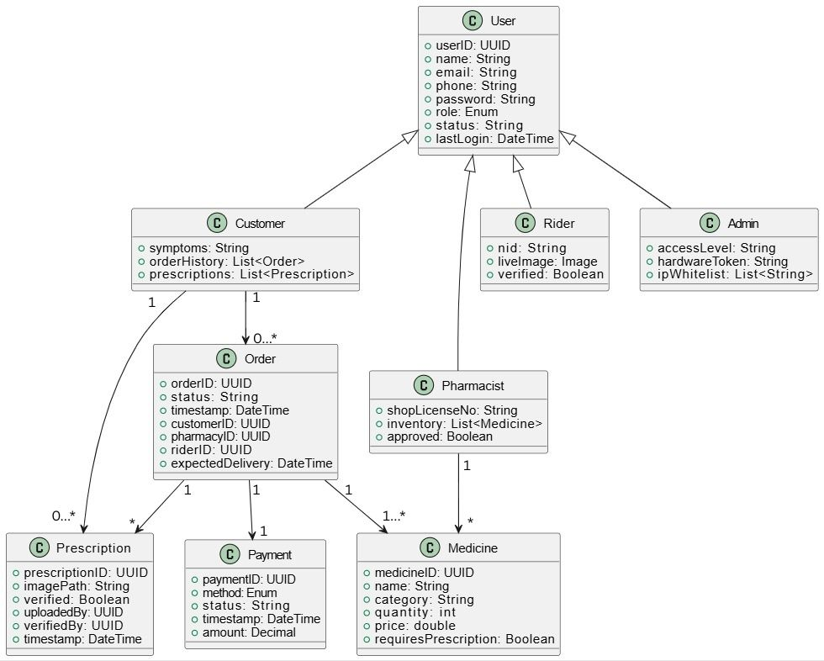

**Description:** User class inherited by four classes customer, pharmacist, rider and admin each class with unique attributes. Customer class is associated with order class and has a relationship with prescription class. Order class is associated with prescription, payment, and medicine class. Pharmacist class has a relationship with medicine class. Order class tracks medicine transactions with delivery and pharmacy details. Medicine class contains data about drugs. Payment class captures the method and status of payment for each order. Prescription class stores and tracks uploaded and verified prescriptions.

**Entity Relationship diagram**

**Description:** User entity stores information about all users such as customers, pharmacist, riders. One user can place many orders, and one user can upload multiple prescriptions. Also, each user action is recorded in an audit log. Order entity represents a medicine order placed by a user. OrderItem entity lists medicines included in each order. One order can include multiple medicine items. Medicine entity contains medicines details and has relationships one to many with orderItem. Payment entity records payment method and date for oders. Each order has one payment record. Delivery entity assigns a rider and date to deliver an order. Each order is linked to a single delivery record. Rider entity stores rider information for deliveries. A rider can handle many deliveries.

**Activity diagram**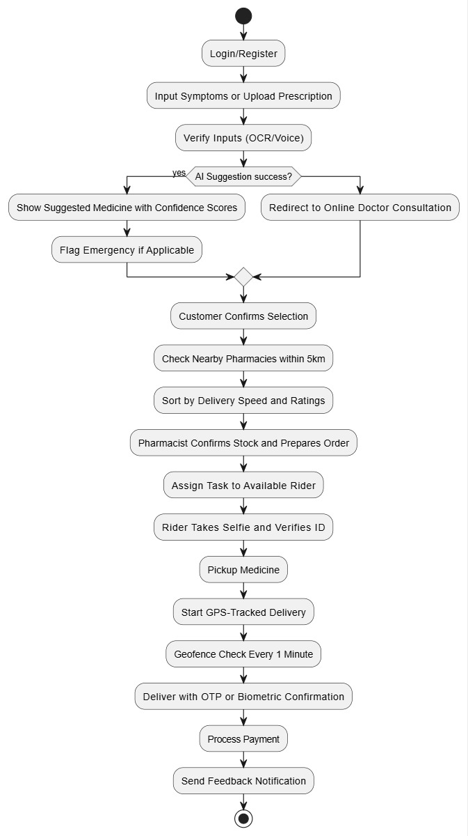

**Description:** The activity diagram begins with login and symptom entry or prescription upload. The system processes input using AI or OCR for suggestions or redirection to a doctor. Based on the selected medicine, the system finds nearby pharmacies. Then assigns a rider after pharmacy confirmation and tracks the rider in real time. After that ensure secure delivery via OTP or biometric verification. And it ends with payment and optional customer feedback.

## Data Dictionary

|  |  |  |  |  |
| --- | --- | --- | --- | --- |
| Entity | Attribute | Type/Size | Validation | Key |
| User | userID | Number(5) | 10000-99999 | Primary |
| User | name | Varchar(100) | required |  |
| User | email | Varchar(100) | Valid email |  |
| User | phone | Varchar(20) | Valid phone number |  |
| User | password | Varchar(255) | Strong password |  |
| User | role | Enum | (Customer, Pharmacist, Rider, Admin) |  |
| Customer | symptoms | TEXT | Optional |  |
| Customer | orderHistory | List | Derived from orders |  |
| Pharmacist | shopLicenseNo | Varchar(50) | Must match approved format |  |
| Pharmacist | inventory | List | Must be up-to-date |  |
| Rider | nid | Varchar(20) | Valid NID |  |
| Rider | liveimage | Image | Real time image format |  |
| Admin | accessLevel | Varchar(20) | (super, limited) |  |
| Admin | hardwareToken | STRING | Encrypted |  |
| Medicine | medicineID | Number(5) | 10000-99999 | Primary |
| Medicine | name | Varchar(100) | Required |  |
| Medicine | category | Varchar(50) | Must match |  |
| Medicine | quantity | INT | >0 |  |
| Medicine | price | DECIMAL | >=0.00 |  |
| Order | orderID | Number(5) | 10000-99999 | Primary |
| Order | timestamp | DATETIME | Auto-timestamped |  |
| Order | status | Varchar(20) | (pending, confirmed, delivered, cancelled) |  |
| Order | customerID | Number(5) | Role=customer | Foreign |
| Order | pharmacyID | Number(5) | Role=pharmacist | Foreign |
| Payment | paymentID | Number(5) | Required | Primary |
| Payment | orderID | Number(5) | Required | Foreign |
| Payment | method | ENUM | (COD, Bkash, Card, Nagad, Rocket) |  |
| Payment | status | Varchar(20) | (pending, success, failed, refounded) |  |

## UI/UX Design Specification

* Select and appropriate tools for prototyping
* Design a prototype of your proposed solution using the selected tools based on the above-mentioned UI/UX design principles.